Input Buffering

Definition:
# Source: AI Source: Provided by: [Data Path: Persons Table -> ID Column: 1, Name_En Column: Motasem Essam] -> From: [Chatgpt (GPT‑5 Mini)] on [12/10/2025]
Input buffering is a technique where data from an input device (like keyboard, file, or network) is temporarily stored in a buffer before the program reads it. This allows the program to read data more efficiently without waiting for the slower input device.

How It Works
# Source: AI Source: Provided by: [Data Path: Persons Table -> ID Column: 1, Name_En Column: Motasem Essam] -> From: [Chatgpt (GPT‑5 Mini)] on [12/10/2025]
- Data is sent from the input device (keyboard, file, etc.) to a buffer in memory.
- The program reads data from the buffer, not directly from the device.
- The buffer may store multiple bytes/records at once to reduce the number of read operations.

Advantages of Input Buffering
# Source: AI Source: Provided by: [Data Path: Persons Table -> ID Column: 1, Name_En Column: Motasem Essam] -> From: [Chatgpt (GPT‑5 Mini)] on [12/10/2025]
- Faster processing: Program reads from memory (buffer) instead of slower devices.
- Reduces idle time: The CPU doesn’t have to wait for the input device.
- Efficient handling of large data: Multiple bytes or records can be read in one operation.

Example
# Source: AI Source: Provided by: [Data Path: Persons Table -> ID Column: 1, Name_En Column: Motasem Essam] -> From: [Chatgpt (GPT‑5 Mini)] on [12/10/2025]
- Typing on a keyboard:
  - When you type, the characters are stored in an input buffer.
  - The program reads them from the buffer when ready.
- Reading a file in Python:
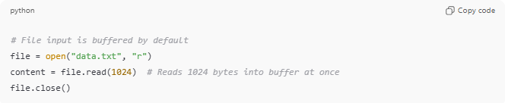
# File input is buffered by default
file = open("data.txt", "r")
content = file.read(1024) # Reads 1024 bytes into buffer at once
file.close()
Here, 1024 bytes are first stored in the buffer, then the program processes them.

Analogy
# Source: AI Source: Provided by: [Data Path: Persons Table -> ID Column: 1, Name_En Column: Motasem Essam] -> From: [Chatgpt (GPT‑5 Mini)] on [12/10/2025]
- Input device → Tap that fills water slowly
- Buffer → A bucket collecting water
- Program → Glass that drinks from the bucket → can get water quickly without waiting for the tap each time

